Homework 4 Arrays and Lists

Gavin Gunawardena

6/25/21

STAT 600

Dr. Claussen

# Instructions

## Reuse

For many of these exercises, you may be able to reuse functions written in prior homework. Include those functions here. You may find that you will need to modify your functions to work correctly for these exercises.

#Convert SAS functions to R and test them  
norm.pdf <- function(x, mu=0, sigma=1) {  
 pi2 <- pi*2  
 var_1 <- sigma^2  
 part1 <- (1/((sigma)*(sqrt(pi2))))  
 part2 <- (exp(((-1*(x-mu)^2/(2*var_1)))))  
 return(round(part1 * part2, 4))  
   
}  
  
  
pois.pmf <- function(x, lambda) {   
 var_fac <- factorial(x)  
 return((exp(-1*lambda)*lambda^x)/var_fac);  
 }  
  
  
 print(pois.pmf(20,1))

## [1] 1.5121013503e-19

print(dpois(20,1))

## [1] 1.5121013503e-19

I’m also including data vectors that can be used in some exercises.

CaloriesPerServingMean <- c(268.1, 271.1, 280.9, 294.7, 285.6, 288.6, 384.4)  
CaloriesPerServingSD <- c(124.8, 124.2, 116.2, 117.7, 118.3, 122.0, 168.3)  
Year <- c(1936, 1946, 1951, 1963, 1975, 1997, 2006)

# Exercise 1

In this exercise, we will test your norm.pdf function with a range of inputs.

**Do not print the vectors you create for this exercise in the final typeset submission** We will check the results by examining the plots, and printing the vectors themselves will unnecessarily clutter your report. If you get stuck, use the built normal functions to create your plots.

### Part a.

Generate a sequence of values from $-3,...,3$ incremented by $0.1$; let this be x_1. Calculate the PDF of each value of x_1 using the norm.pdf function from Homework 3, letting mu=0 and sd=1. Plot the PDF curve ( $norm.pdf$ is the dependent variable, $x$ is independent) as a line graph.

#Set variables and do calculations  
x_1 <- seq(-3.0,3,0.1)  
x_1_pdf <- norm.pdf(x_1)  
  
  
#plot data  
plot(x_1,x_1_pdf,type='l',ylab='Prob. Density Func.',xlab='X',col='blue');

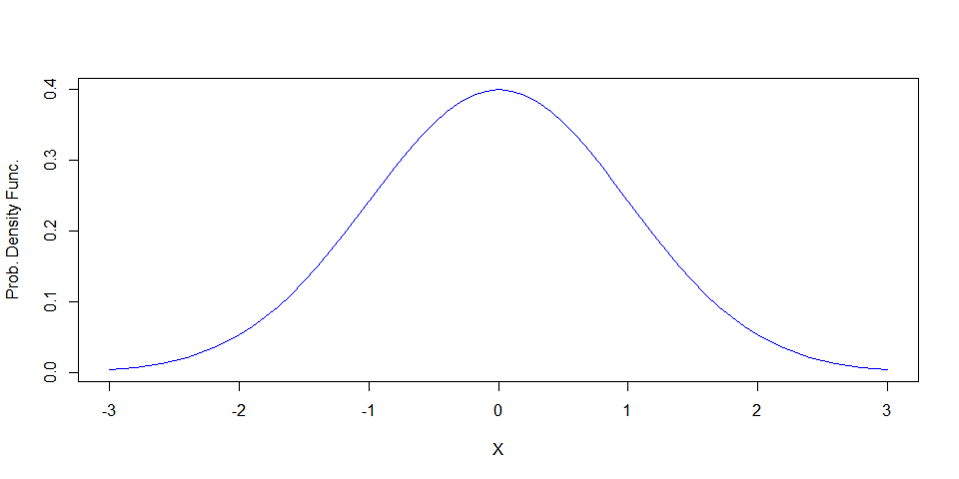

### Part b.

Let $m_{1936}$ be the mean Calories per Serving from 1936, and let $m_{2006}$ be the mean Calories per Serving, 2006. Let $s_{1936}$ and $s_{2006}$ be the corresponding standard deviations.

Create two sequences and name these x_2 and x_3. Define x_2 to be a range of values $[m_{1936}-3×s_{1936},…,m_{1936}+3×s_{1936}]$ and define x_3 to be $[m_{2006}-3×s_{2006},…,m_{2006}+3×s_{2006}]$. x_2 and x_3 should be the same length as x_1.

Calculate the corresponding pdf for these sequences, using $\{μ=m_{1936},σ=s_{1936}\}$ with x_2 and use $\{μ=m_{2006},σ=s_{2006}\}$ with x_3.

As with part a, plot the pdf curve for both sequences, but include both in the same graph. Use two different colors or line types for each curve. You may need to use min and max to find xlim values or ylim to fit both curves on the same plot. The first curve in this graph should appear identical to the curve in part a; the second curve will be similar but will differ in location and spread.

#Set variables and do calculations  
m_1936 <- CaloriesPerServingMean[1]  
m_2006 <- CaloriesPerServingMean[7]  
s_1936 <- CaloriesPerServingSD[1]  
s_2006 <- CaloriesPerServingSD[7]  
x_2 <- seq(m_1936-3*s_1936,m_1936+3*s_1936,s_1936*.1)  
x_3 <- seq(m_2006-3*s_2006,m_2006+3*s_2006,s_2006*.1)  
 # print(x_2)  
 # print(x_3)  
x_2_pdf <- norm.pdf(x_2,m_1936,s_1936)  
x_3_pdf <- norm.pdf(x_3,m_2006,s_2006)  
# print(x_2_pdf)  
# print(x_3_pdf)  
  
#plot  
x <- seq(-5,5,.1)  
plot(x_2,x_2_pdf,type='l',main='Probability Density 1936 vs 2006 Calories Per Serving' ,ylab='Prob. Density Func.',xlab='X',col='blue',ylim=c(min(x_2_pdf),max(x_2_pdf)),xlim=c(min(x_2),max(x_2)));  
lines(x_3,x_3_pdf,col='green',lty=2);  
legend('topleft', legend = c("1936 (x_2)", "2006 (x_3)"),  
 pch = c(NA,NA), lty = c(1, 2),  
 col = c('blue','green'))

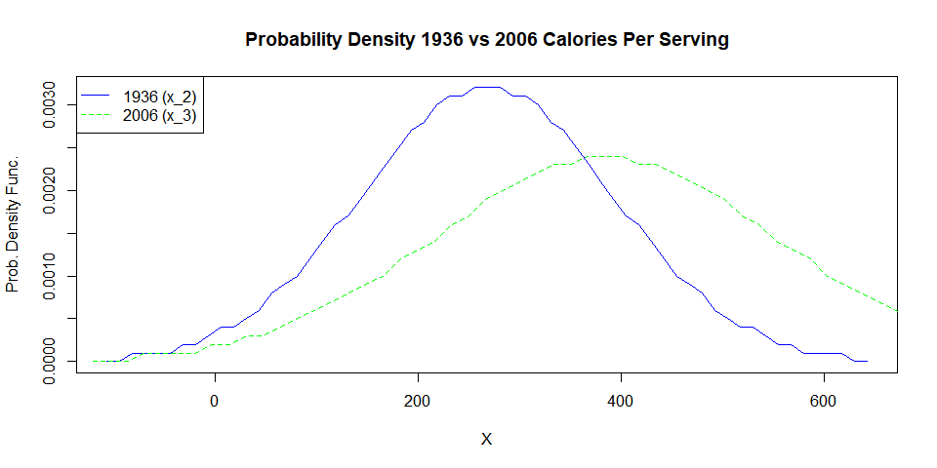

If you choose to solve this with SAS, I’ve included code in the SAS template to create the graphs, since combining plots in IML is not as easy as in R.

If you wish, you may reproduce the curves using dnorm to compare with your function.

# Exercise 2

Suppose we wish to determine the relationship between per Calories per Serving and Year. We can determine this by solving a system of linear equations, of the form

$$\begin{matrix}268.1 & =β_{1}+β_{2}×1936 \\ 271.1 & =β_{1}+β_{2}×1946 \\ ⋮ & =⋮ \\ 384.4 & =β_{1}+β_{2}×2006\end{matrix}$$

We write this in matrix notation as

$$\left(\begin{matrix}268.1 \\ 271.1 \\ ⋮ \\ 384.4\end{matrix}\right)=\left(\begin{matrix}1 & 1936 \\ 1 & 1946 \\ ⋮ & ⋮ \\ 1 & 2006\end{matrix}\right){\left(\begin{matrix}β_{1} \\ β_{2}\end{matrix}\right)}^{t}$$

We can also write this as

$$y=Xβ$$

and find a solution by computing $\hat{β}=X^{-1}y$.

However, an exact solution for the inverse, $X^{-1}$ require square matrices, so commonly we use the *normal* equations,

$$X^{t}y=X^{t}Xβ$$

(where $X^{t}$ is the transpose of $X$). We then find

$$\hat{β}={\left(X^{t}X\right)}^{-1}X^{t}y$$

### Answer

Define appropriate X and y matrices (y can be a vector in R) in the chunk below.

Multiply the transpose of X by X, then use solve (R) or inv (IML) to find the inverse ${\left(X^{t}X\right)}^{-1}$. Multiply this by the product of transpose X and y to find hat.beta.

Print your hat.beta.

X_m <- Year   
y_m <- CaloriesPerServingMean  
x <- matrix(cbind(1,X_m),nrow=7,ncol=2)  
y <- matrix(cbind(y_m),nrow=7,ncol=1)  
transpose_times_x <- t(x) %*% x  
  
 hat.beta <- solve(transpose_times_x)%*%t(x)%*%y  
 hat.y <- x%*%hat.beta  
 # print(hat.y)  
 print(hat.beta)

## [,1]  
## [1,] -1965.37260726008  
## [2,] 1.14933993399

To check your work, calculate the values predicted by your statistical model. Compute hat.y by multiplying X and hat.beta,

$$\hat{y}=X\hat{β}$$

Plot y vs the independent variable (the second column of X) as points, and hat.y vs independent variable as a line, preferably a different colors. The hat.y values should fall a straight line that interpolates y values.

#Plot Check  
plot(x[,2],hat.y,type='l',ylab='y hat value',xlab='Year',col='blue',xlim=c(min(x[,2]),max(x[,2])),ylim=c(min(hat.y),max(hat.y)))  
lines(x[,2],y,col='green',lty=2)

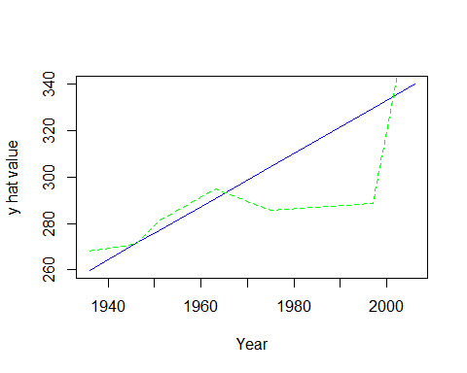

You can also compare your result to the R function (set eval=TRUE).

#,eval=False}  
summary(lm(CaloriesPerServingMean~Year))

##   
## Call:  
## lm(formula = CaloriesPerServingMean ~ Year)  
##   
## Residuals:  
## 1 2 3 4 5 6   
## 8.35049505 -0.14290429 3.91039604 3.91831683 -18.97376238 -41.25924092   
## 7   
## 44.19669967   
##   
## Coefficients:  
## Estimate Std. Error t value Pr(>|t|)   
## (Intercept) -1965.372607261 875.878613771 -2.24389 0.074849 .  
## Year 1.149339934 0.445090776 2.58226 0.049297 *  
## ---  
## Signif. codes: 0 '***' 0.001 '**' 0.01 '*' 0.05 '.' 0.1 ' ' 1  
##   
## Residual standard error: 28.6917147 on 5 degrees of freedom  
## Multiple R-squared: 0.571479922, Adjusted R-squared: 0.485775906   
## F-statistic: 6.66806471 on 1 and 5 DF, p-value: 0.0492969117

#### Alternative methods

You can also compute $\hat{β}$ by passing both $X^{t}X$ and $X^{t}y$ as arguments to solve.

Alternatively, you can install the MASS library and use ginv to compute a generalized inverse $X^{-1}$. Use this to compute $\hat{β}=X^{-}y$ in the chunk below:

library(MASS)  
print(hat.beta <- ginv(X) %*% y)

# Exercise 3

Given a vector of mean estimates $x=x_{1},x_{2},…,x_{k}$, a vector of standard deviations $s=s_{1},s_{2},…,s_{k}$ and a vector of sample sizes $n=n_{1},n_{2},…,n_{k}$, we can calculate a one-way analysis of variance by



and



where $\overset{‾}{x}$ is the weighted mean of $x_{i}$, where and. The test statistic is $F=\frac{MSB}{MSW}$ which is distributed as $F_{α,k-1,N-k}$

### Part a

Calculate MSW and MSB for Calories per Serving from Wansink Table 1. You can use the variables CaloriesPerServingMean and CaloriesPerServingSD defined below. Let $n_{1}=n_{2}...=n_{k}=18$

Use array functions and arithmetic for your calculations, you should not need iteration (for loops). Do not hard code values for $N$ and $k$, calculate these from the CaloriesPerServingMean or CaloriesPerServingSD.

Print both MSB and MSW.

msb.solve <- function(x,sample_size) {  
 #x can be either standard deviation or mean  
 x_weighted_avg <- weighted.mean(x, rep(1,7))  
 #print(x_weighted_avg)  
 iterations <- rep(sample_size,length(x))  
 #print(iterations)  
 pt_1 <- sum(iterations%*%(x-x_weighted_avg)^2)  
 pt_2 <- length(x) - 1  
 return(pt_1/pt_2)  
}  
MSW.solve <- function(x, sample_size) {  
 #x must be standard deviation  
 iterations <- rep(sample_size,length(x))  
 pt_1 <- sum((iterations-1)*(x^2))  
 pt_2 <- sum(iterations)-length(x)  
 return(pt_1/pt_2)  
}  
  
#Print Results  
print('Mean Square Between Groups:')

## [1] "Mean Square Between Groups:"

print(msb.solve(CaloriesPerServingMean,18))

## [1] 28815.96

print('Mean Square Within Groups:')

## [1] "Mean Square Within Groups:"

print(MSW.solve(CaloriesPerServingSD,18))

## [1] 16508.5985714

### Part b

Calculate an F-ratio and a $p$ for this $F$, using the $F$ distribution with $k-1$ and $N-k$ degrees of freedom. Use $α=0.05$. Compare these values to the corresponding values reported in Wansink Table 1.

#Set variables and do calculations  
df1 <- length(CaloriesPerServingMean)-1  
df2 <- sum(rep(18,length(CaloriesPerServingMean)))-length(CaloriesPerServingMean)  
MSB <- msb.solve(CaloriesPerServingMean,18)  
MSW <- MSW.solve(CaloriesPerServingSD,18)  
f_stat <- MSB / MSW  
p_val <- pf(f_stat,df1,df2,lower.tail=FALSE)  
  
#Print values:  
print('F Statistic')

## [1] "F Statistic"

print(round(f_stat,4))

## [1] 1.7455

print('P Value')

## [1] "P Value"

print(round(p_val,4))

## [1] 0.1163

*Compared to the results shown in Wansink Table 1 for average calories per serving, these above obtained results are vastly different, with the P value I obtained being farther from 0. Also, the F value I obtained is less than the F critical value which, with an alpha level of .05, is 2.1750(going by an F chart), while the F value obtained by Wansink was 436.9 which is higher than the critical value, although from doing some research, it seems it’s best not to solely use the F value but instead use it with the results of a P value or another test for checking statistical significance.*

You can also check results by entering appropriate values in an online calculator like <http://statpages.info/anova1sm.html> .

# Exercise 4

In this, we compare the normal and Poisson distributions, using the functions you’ve written previously. This is also a way to test your normal and Poisson functions over a range of arguments.

**Do not print the vectors you create for this exercise in the final typeset submission** We will check the results by examining the plots, and printing the vectors themselves will unnecessarily clutter your report. If you get stuck, use the built functions to create your plots. However, the final submission must call your functions.

### Part a

Create a sequence of $x_{a}$ from $(-5...5)$, incremented by 0.1. Calculate the normal PDF for each $x$, assuming $μ=0$ and $σ=1$. Also calculate Poisson PMF of each $x$ given a lambda=1.

Plot both sets of probabilities against x_a as lines, using a different color for each curve. Make sure that both curves fit in the plot; you may need to determine minimum and maximum values and set these as graphic parameters (see ylim).

Warning: if you do this in SAS, you may have to adjust the lower bound of $x$.

#Set variables and do calculations  
x_q4a <- seq(-5.0,5,0.1)  
x_q4a_norm <- norm.pdf(x_q4a)  
 x_q4a_pois <- pois.pmf(ceiling(x_q4a),1)

## Warning in gamma(x + 1): NaNs produced

#Alternative for testing  
 #x_q4a_pois <- pois.pmf(x_q4a,1)  
 # x_q4a_pois <- dpois(ceiling(x_q4a),1)  
  
  
#plot  
plot(x_q4a,x_q4a_norm,type='l' ,ylab='Prob. Density Func.',xlab='X',col='blue',ylim=c(min(x_q4a_norm),max(x_q4a_norm)),xlim=c(min(x_q4a),max(x_q4a)));  
lines(x_q4a,x_q4a_pois,col='green',lty=2);  
legend('topleft', legend = c("normal", "poisson"),  
 pch = c(NA,NA), lty = c(1, 2),  
 col = c('blue','green'))

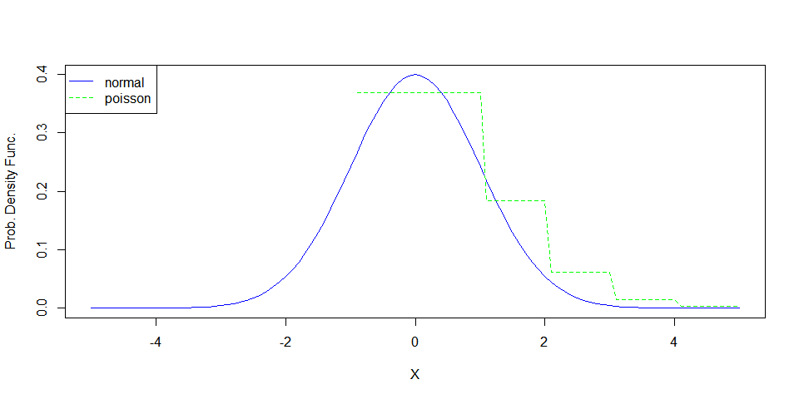

Does this graph tell you if your Normal PDF function behaves properly? Does your Poisson handle negative or non-integer values as expected? You might need to call a rounding function on the parameters inside your function.

*Yes, I believe it does since, at least for positive values, it follows the normal distribution. No, my Poisson function does not handle negative or non-integer values as expected, especially compared to the built-in Poisson function. From what I understand from doing some research, this is due to the factorial function in R not working with negative numbers and thus I’m getting some null results. From testing it, rounding functions do not seem to have an effect on the plot.*

### Part b

Create a sequence of $x_{b}=\left\lfloor μ-5×σ\right\rfloor ,…,\left\lceil μ+5×σ\right\rceil$ using mean and standard deviation for Servings per Recipe from 1936.

Calculate the normal and Poisson probability for each $x_{b}$ as in part a, again using mean and standard deviation from servings per recipe, 1936. The length of this vector should be the same length as the $x_{a}$ vector as in part a ($±1$), so you will need to calculate an interval based on the range x_b and the number of elements in x_a

Show the the length of both $x$ vectors are similar by calling length for each.

Repeat the plot from part a with this sequence.

If you choose to solve this with SAS, I’ve included code in the SAS template to create the graphs, since combining plots in IML is not as easy as in R.

m_1936 <- CaloriesPerServingMean[1]  
s_1936 <- CaloriesPerServingSD[1]  
x_q4b <- seq(m_1936-5*s_1936,m_1936+5*s_1936,s_1936*.1)  
#print(x_q4b)  
  
#normal probability  
x_q4b_norm <- norm.pdf(x_q4b,m_1936,s_1936)  
  
#tested alternative  
# x_q4b_norm <- dnorm(x_q4b,m_1936,s_1936)  
  
  
#Poisson probability  
x_q4b_pois <- pois.pmf(ceiling(x_q4b),1)

## Warning in gamma(x + 1): NaNs produced

#Tested alternatives  
# x_q4b_pois <- dpois(x_q4b,1)  
# x_q4b_pois <- dpois(ceiling(x_q4b),1)  
  
   
#lengths  
print('question 4a length')

## [1] "question 4a length"

(length(x_q4a))

## [1] 101

print('question 4b length')

## [1] "question 4b length"

print(length(x_q4b))

## [1] 101

#plot  
plot(x_q4b,x_q4b_norm,type='l',main='1936 Normal vs Poisson Probability' ,ylab='Prob. Density Func.',xlab='X',col='blue',ylim=c(min(x_q4b_norm),max(x_q4b_norm)),xlim=c(min(x_q4b),max(x_q4b)));  
lines(x_q4b,x_q4b_pois,col='green',lty=2);  
legend('topleft', legend = c("normal", "poisson"),  
 pch = c(NA,NA), lty = c(1, 2),  
 col = c('blue','green'))

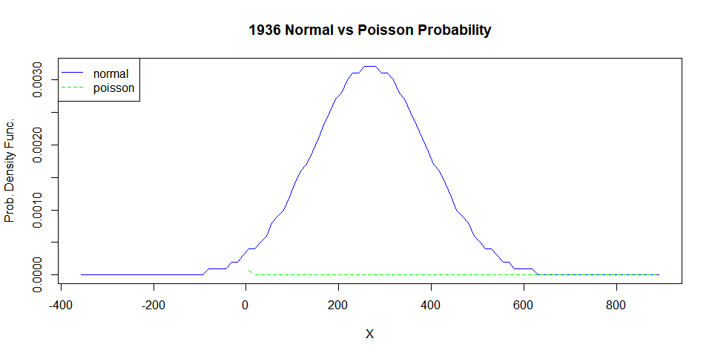

To check you work, duplicate the plots by calling built in normal and Poisson functions. Does the built in Poisson function handle negative $x$ differently than your function?

*In this case I’m getting much different results than in 4a. The poisson distribution isn’t following the normal distribution via the built in poisson distribution function nor with my version. These functions are getting very opposite results when not rounded, with my function getting results that include infinite values and the built-in function getting results that include 0 values. When rounded, these 2 functions are getting very similar results that don’t follow the normal distribution. Also, when rounded, my poisson distribution function seems to stop at negative values compared to the built in function which seems to still work on negative values.*